

**Exploratory Data Analysis (EDA)**

For used car market in UK

Presented by:

Ammer saleh

Naif alsulihem

21 November, 2021

# Introduction

The history of transportation starts from the age of humans and has continued to change over some time. The first means of transportation was the human foot. The history of transport has undergone a radical change with the introduction of wheels. Existing means of transportation were continuously improved after that, for example, horse-drawn vehicles (carts or karts). Until the gas and fuel cars were invented Cars are one of the most important necessities for every family, as they are the most popular means of transportation these days.

This project aims to analyze the used car market in the UK, compare car prices by type, engine, and car model, for example, which cars are most in demand. With the presence of more than one car company.

We will do a comprehensive analysis to find the best used cars to attract customers so that our showrooms are among the best and we can achieve the company's goal and vision for development in the used car sectors.

# Study [Methodolog](https://github.dihe.moe/sanjeevai/nyc_subway_data_analysis#p2)y

The methodology of this project is as follows, extracting data from Kaggle which is used cars in the UK and it was more than 33,000 rows and 9 columns.

In the cleaning step, we dropped the tax column because it is not included in our study, and we dropped the missing values in the dataset and the anomalous values.

We explored the data and applied comprehensive analysis methods to the data and extracted important information from the data, for example, what are the top 5 used cars that were purchased, what years of manufacture are the most purchased ... , and know what is focused on the buyer in the used car market in the UK.

# Data Description

The data set is provided in .csv format, contains information of price, transmission, model, mileage, fuel type, road tax, miles per gallon (mpg), and engine size.

The data set was extracted from Kaggle

|  |  |
| --- | --- |
| **Variables** | **Description** |
| **Model** | In this column, the model of the car shows us the name of the car.(e.g., ford Kuga.) |
| **Year** | In this column, shows the year of manufacture of the car (e.g., 2012) |
| **Price** | This column shows the cost of car (e.g., 60000) |
| **Transmission** | It shows us the type of car transmission (e.g., Manual) . |
| **Mileage** | In this column, It shows us the distance the car has traveled in miles |
| **Fuel type** | in this column, it shows us the type of fuel (e.g., Petrol) |
| **Engine** | Size In this column, it shows us the engine capacity of the car |
| **Mpg** | In this column, it shows us the distance covered by the car per gallon |
| **Tax** | In this column, the tax amount charged on the car |

# Tools and Libraries:

* Python.
* Jupyter Notebook.
* PowerPoint.
* Excel
* NumPy.
* Pandas.
* Matplotlib

# Data analysis

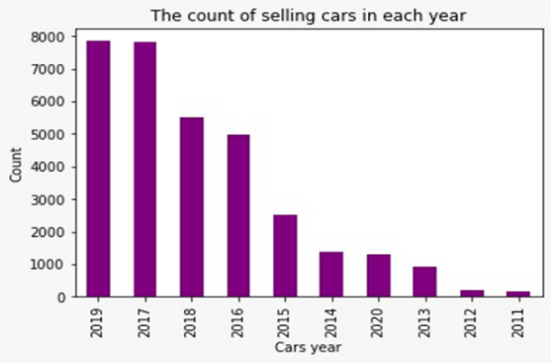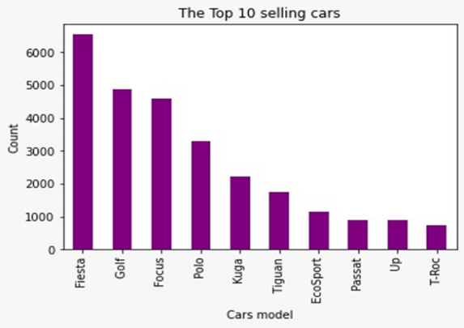 After we prepared the data, Then we used some of visualisation tools such as seaborn and matplotlib to look what is the most common used car in UK model most manufacturer year of our data set .

This graph shown the correlation between price, year, mileage, and we conclude that the prices of used cars will rise when the Mile Age

This bar graphs shows most popular Fiesta year is 2019 and the mean price is 14,371 Pound .

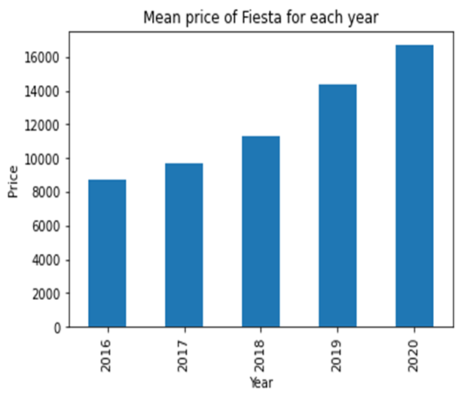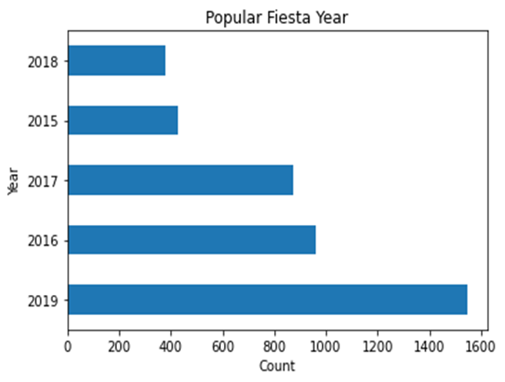

This graph shown the percentage of transmission for Fiesta and fuel type.

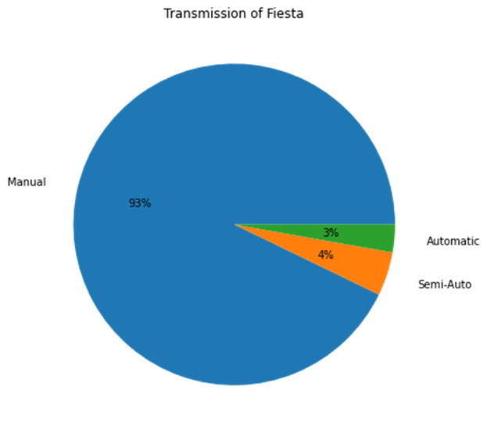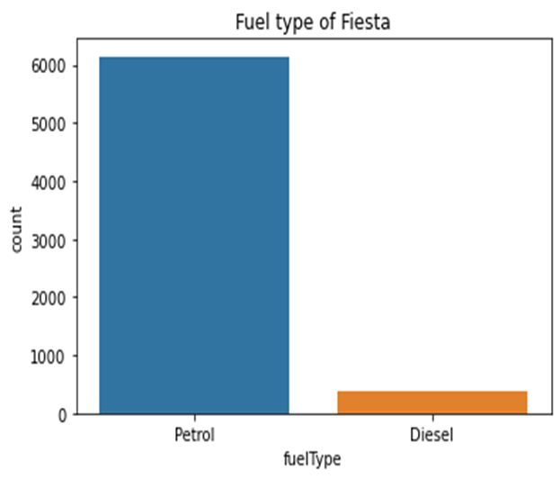

This graph show the most common Engine which is 1.5 and the mean mileage for Fiesta for each year and we noticed the mean mileage for 2019 is 7502 kilo.

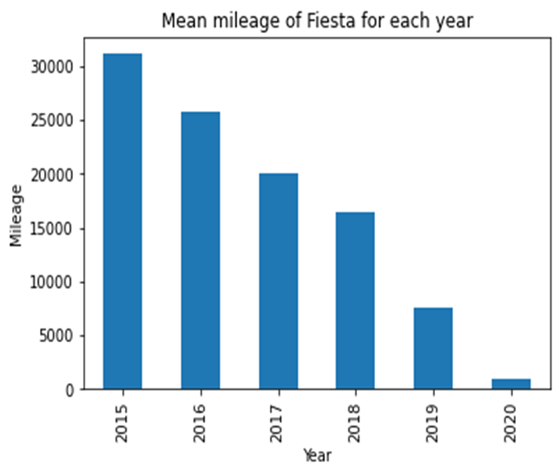

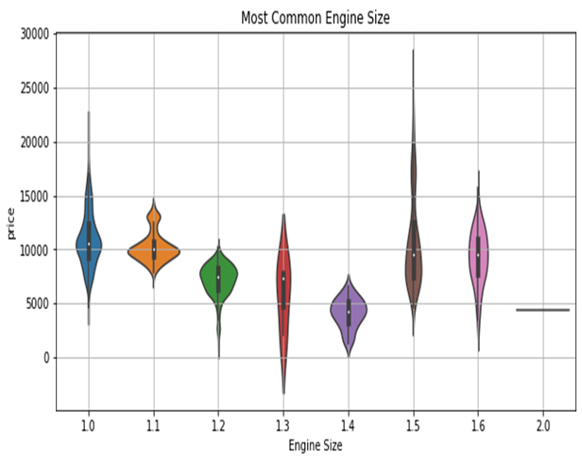

# Conclusion

* So the top 5 used car is Fiesta, Golf, Focus, Polo, Kuga.
* The most common manufacturer year is 2019
* We will focus in top 5 cars to make our exhibition more competitive and attract the costumer, but the exhibition will be diversified at the same time so that everyone has the choices.
* We found that the newer car will be more expansive, and the lower mileage also increase the price.

**Reference**

1. <https://www.kaggle.com/adityadesai13/used-car-dataset-ford-and-mercedes>